.;Step 1-

Data Requirements-

1. To base concept of our database system is that a person can make a request for a cab to go to some place and there must be a driver and a car available to take him to the new destination.

2. For this we highlight our main entities are-

a. Customer

b. Driver

c. Cab

d. Service Request

e. Payment methods for the cab

f. Area specifications- Zone

To enhance our database model we are added a feature of Peak time determination for the convenience of the company so that they can maintain good profits from areas of high booking rates. Hence our last entity would be-

g. Peak time

Step-2

We designed a well defined EER diagram for our given Taxi Services Database System.

Following the required Specifications our system Design contains the relations with min max ratio as-

a. two one-to-one binary relationships-

1. The Service request to Payment Relationship- For every Service Request there would be at least one Payment Request. Also every payment will depend on at max one service request.

2. Driver to Cab Relation- A Driver can drive only a particular cab to ensure security issues and if a driver has changed his car, he or she needs to make a new account. A cab can be driven by only one driver.

b. two one-to-many binary relationships.-

1. Service Request to Customer Relationship- A particular service request is made by 1 customer nut a customer can make many service requests form time to time.

2. Service Request to Driver- Similar to the previous reason, each service request can be made to only one driver but a driver can take up multiple service requests.

c. two many-to-many binary relationships-

1. The Driver to Zone relationship- A Driver can be in many zones while driving and a zone can have many drivers taking service requests.

2. Zone to Peak time- A peak time can include many zones and a zone can have many peak times.

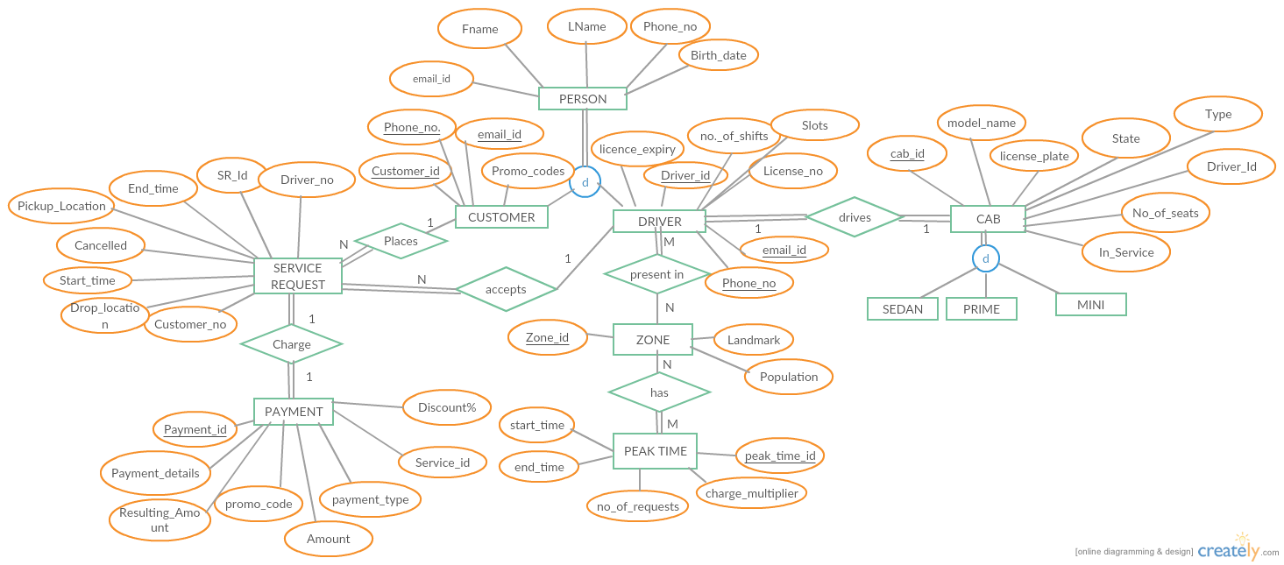

Step-3

The relational schema of the given ER diagram can be mapped as follows.

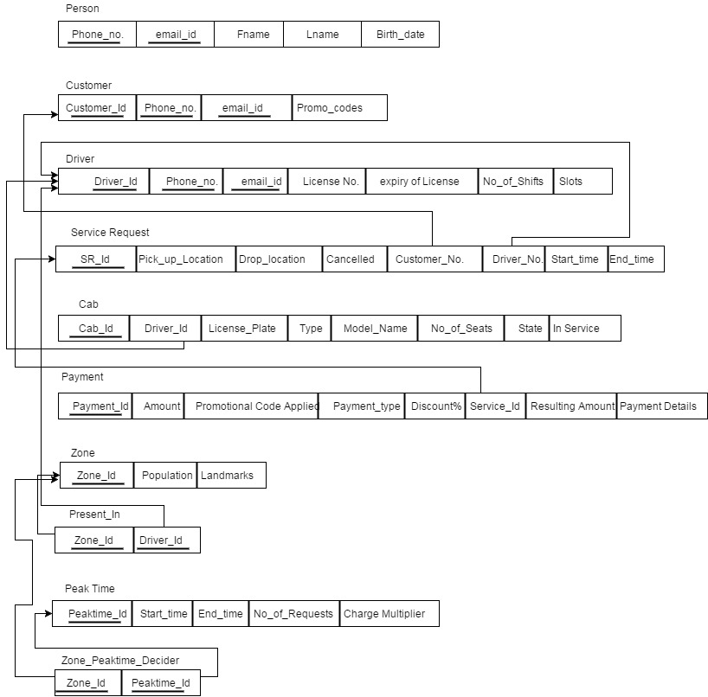

Step 4- Discussing the Normalization

